CTA/Orange Service Center Council
http://www.cta-oscc.org/
Presidents’ Summit
September 28, 2016
Continental Breakfast and Lunch Provided
9:00 AM – 2:30 PM

Presidents’ Idea Exchange
(Please list items you would like to share or discuss.)

Orange RRC
281 N. Rampart, Suite A Orange, CA 92868
714/978.8861
Map Attached

Reservation Deadline Friday, September 23
Chapter Name:
President or Designee’s Name:
If Designee, Please List Title:

OSCC will reimburse chapters for release time for the president or designee. If requesting release, please complete section below:

District Name: |  |  |  |  | Attention:
District Address:
City: |  |  |  | Zip:

EMAIL reservation form to:
Tami Beseda (tbeseda@cta.org)
(714) 978.8861 FAX (714) 978.2423
MAP
Orange RRC
281 N. Rampart, Suite C
Orange, CA 92868
(714) 978-8861

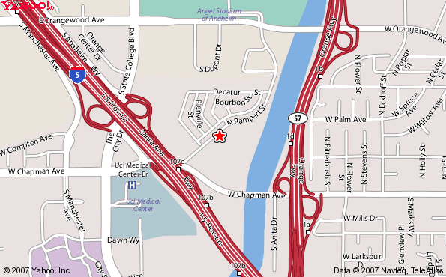

Northbound on the 5 Freeway:
- Exit on Chapman Avenue (just past the 5/22/57 freeway intersection)
- At the light, turn right onto Chapman Avenue.
- At the next light, turn left onto Rampart Street.
- Go about one block; turn right into parking lot of our office building complex
(directly across from main entrance to Mobile Home Park).
- Once in parking lot, turn right; office is at the end of the parking lot.
- If parking lot is full, go back to Rampart, turn right, and go down to next office building complex.

Southbound on 5 Freeway
- Exit State College.
- At the first light, go straight (it will look like you are getting back on the freeway).
- At the next light, turn left on to Chapman Avenue.
- At the next light, turn left onto Rampart Street.
- Go about one block; turn right into parking lot of our office building complex
(directly across from main entrance to Mobile Home Park).
- Once in parking lot, turn right; office is at the end of the parking lot.

From the 57:
- Exit at Orangewood and go west.
- Cross the Santa Ana Riverbed.
- At the next light, turn left onto Rampart Street (by the Fire Dept. training center).
- Go past the fire training center and curve to the right.
- Go past the mailboxes on the left and take the next left into the parking lot of our office building complex (directly across from main entrance to Mobile Home Park).
- Once in parking lot, turn right; office is at the end of the parking lot.

